*salt_pepper_noise.cpp*

1. Code Explanation

1) overall explanation

Color, grayscale 각각의 이미지에 대해 Salt-pepper noise가 있는 이미지와 median filtering을 이용하여 noise를 제거한 이미지를 생성하는 파일이다.

2) code

Salt_pepper_noise_removal_Gray 함수(다음 페이지에)

if (!strcmp(opt, "zero-padding")) {

int idx = 0; //index at the filter kernel

for (int x = -n; x <= n; x++) { // for each kernel window

for (int y = -n; y <= n; y++) {

if ((i + x <= row - 1) && (i + x >= 0) && (j + y <= col - 1) && (j + y >= 0))

kernel.at<G>(idx++, 0) = input.at<G>(i + x, j + y);

else kernel.at<G>(idx++, 0) = 0;

}

}

median = kernel_size * kernel_size / 2;

}

else if (!strcmp(opt, "mirroring")) {

int idx = 0; //index at the filter kernel

for (int x = -n; x <= n; x++) { // for each kernel window

for (int y = -n; y <= n; y++) {

if (i + x > row - 1) //mirroring for the border pixels

tempa = i - x;

else if (i + x < 0)

tempa = -(i + x);

else

tempa = i + x;

if (j + y > col - 1)

tempb = j - y;

else if (j + y < 0)

tempb = -(j + y);

else

tempb = j + y;

//push mirrored elements to the kernel

kernel.at<G>(idx++, 0) = input.at<G>(tempa, tempb);

}

}

median = kernel_size * kernel_size / 2;

}

else if (!strcmp(opt, "adjustkernel")) {

int idx = 0; //index at the filter kernel

for (int x = -n; x <= n; x++) { // for each kernel window

for (int y = -n; y <= n; y++) {

//image boudary안의 있는 픽셀들에 대해서만 median filtering 을 한다

if ((i + x <= row - 1) && (i + x >= 0) && (j + y <= col - 1) && (j + y >= 0))

kernel.at<G>(idx++, 0) = input.at<G>(i + x, j + y);

}

}

median = idx / 2;

}

Salt_pepper_noise_removal_RGB 함수의 경우: Gray 함수와 유사하다. 대신 input의 각 채널의 intensity를 kernel의 0번째, 1번째, 2번째 column에 저장해 준다.

kernel.at<G>(idx, 0) = input.at<C>(i + x, j + y)[0];

kernel.at<G>(idx, 1) = input.at<C>(i + x, j + y)[1];

kernel.at<G>(idx, 2) = input.at<C>(i + x, j + y)[2];

idx++;

output.at<C>(i, j)[0] = kernel.at<G>(median, 0);

output.at<C>(i, j)[1] = kernel.at<G>(median, 1);

output.at<C>(i, j)[2] = kernel.at<G>(median, 2);

3) analysis and explanation of the code

각 boundary processing method에 따라 kernel에 input의 원소들을 순차적으로 저장해 준다. Kernel에 저장된 값을 오름차순으로 sort한 후, median 값을 output에 저장한다.

2. Results & analysis and explanation

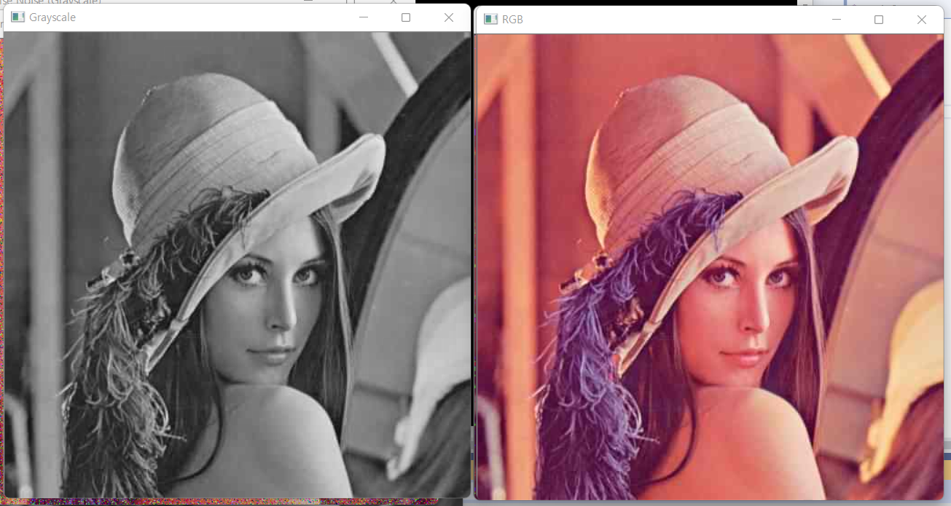

Original image

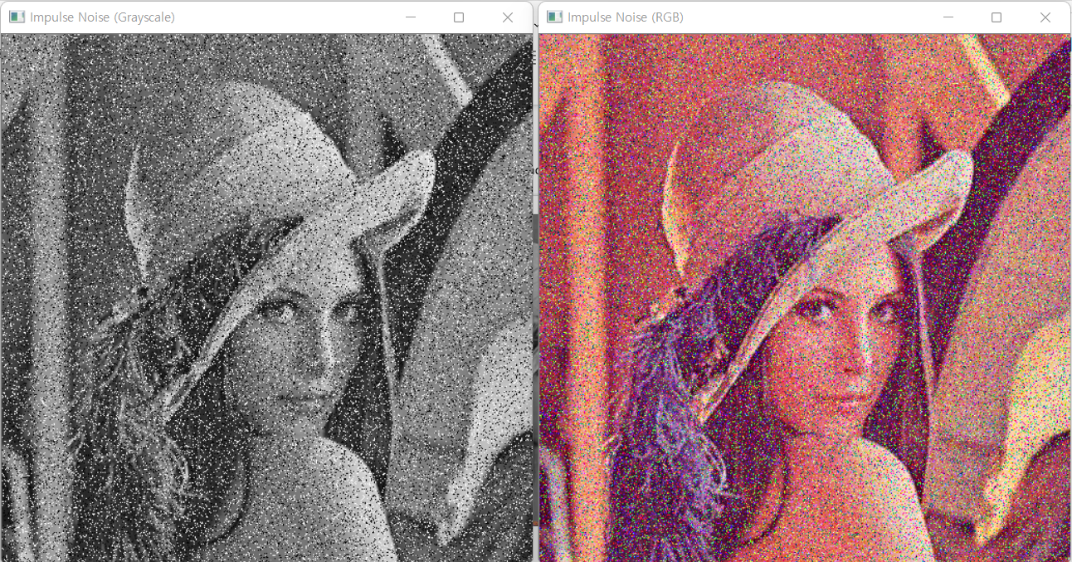

Image with the salt-and-pepper noise (density of salt noise=0.1, density of pepper noise=0.1)

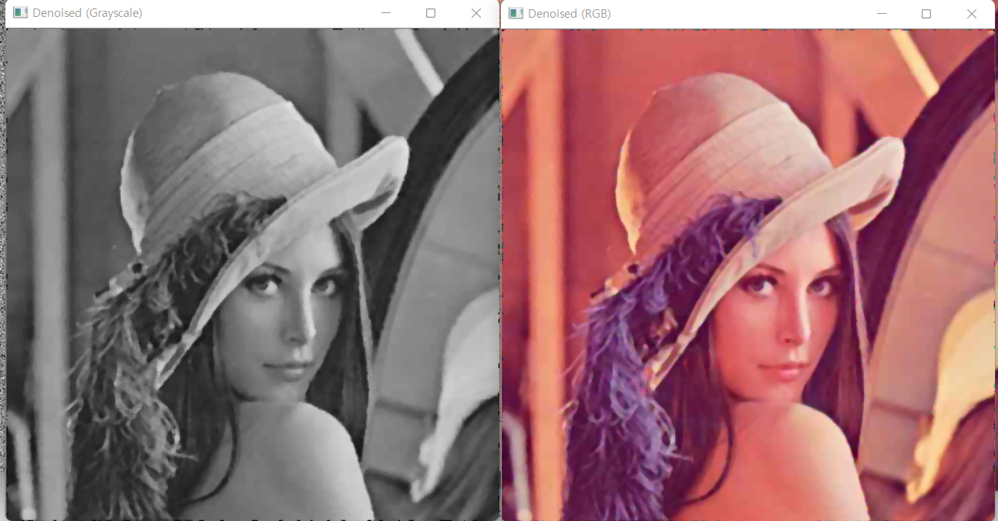

Salt-and-pepper noise removed with the median filtering (5x5, zero-padding)

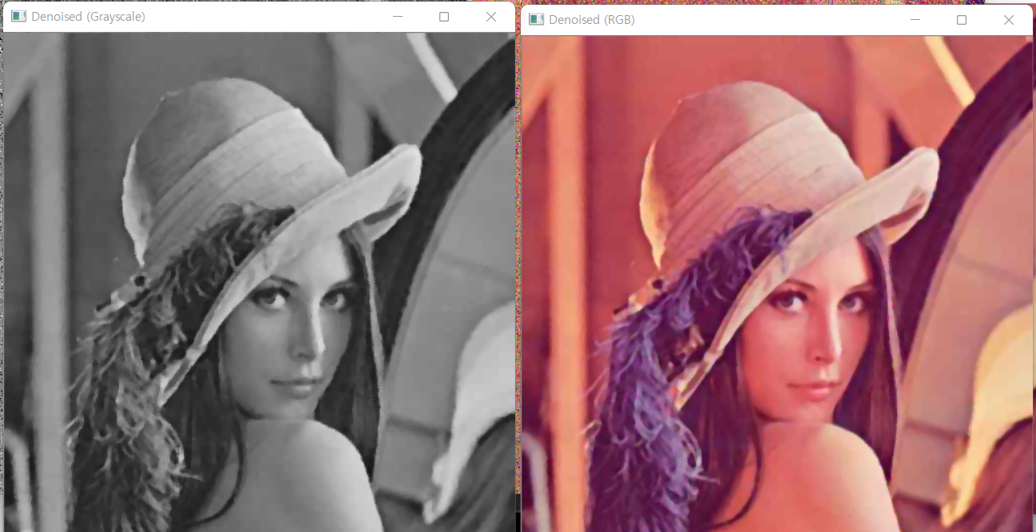

Salt-and-pepper noise removed with the median filtering (5x5, mirroring)

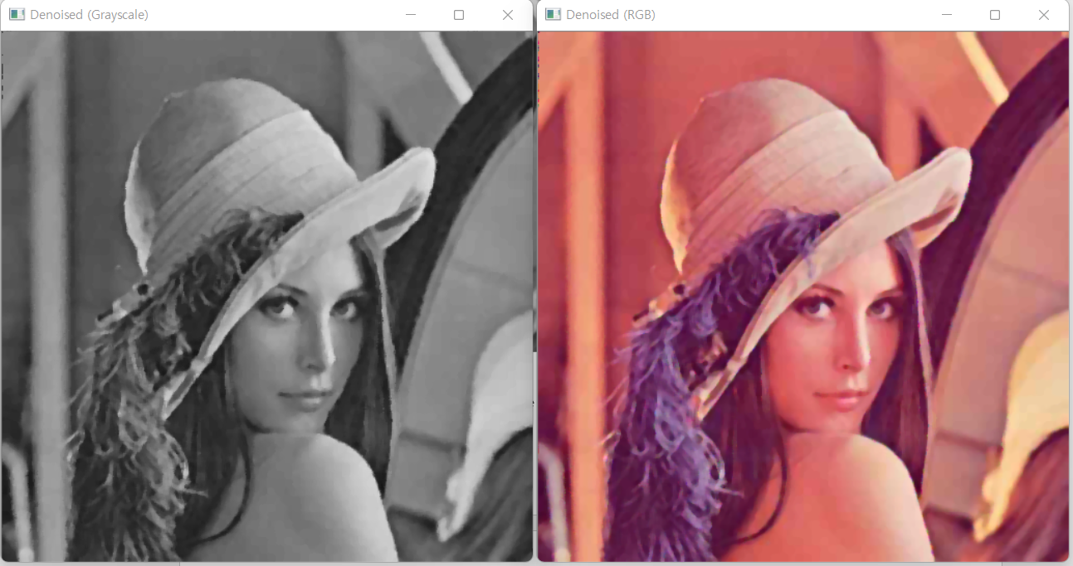

Salt-and-pepper noise removed with the median filtering (5x5, adjustkernel)

*gaussian_noise_gaussian.cpp*

1. Code Explanation

1) overall explanation

Gaussian noise를 가진 각각의 흑백, 컬러 이미지를 생성한 뒤, gaussian filter를 이용하여 noise를 제거한 이미지들을 생성한다.

2) code & analysis and explanation of the code

Gaussianfilter_Gray의 과정은 다음과 같다.

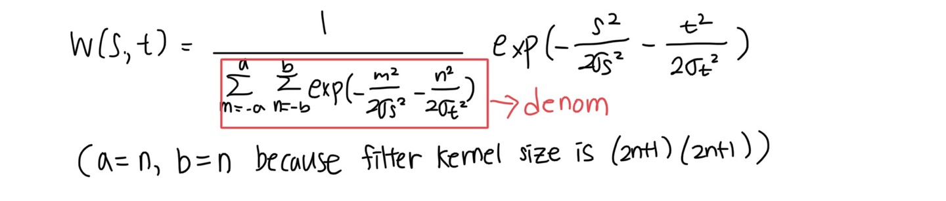

1. (a, b) 각 좌표별로 2D gaussian function value를 계산하여 kernel matrix에 저장하고, kernel matrix 의 원소들의 합을 구하여 denom에 저장한다. Gaussian function을 계산할 때 math.h 라이브러리에 있는 exp() 와 pow() 함수를 이용한다.

denom = 0.0;

for (int a = -n; a <= n; a++) { // compute denominator value and elements of kernel

for (int b = -n; b <= n; b++) {

float value1 = exp(-(pow(a, 2) / (2 * pow(sigmaS, 2))) - (pow(b, 2) / (2 * pow(sigmaT, 2))));

kernel.at<float>(a + n, b + n) = value1;

denom += value1;

}

}

1. Kernel matrix의 모든 원소들의 값을 denom으로 나눠 준다. 이는 normalization을 통하여 filter kernel의 모든 값의 합이 1이 되도록 하기 위함이다.

for (int a = -n; a <= n; a++) { // divide kernel with Denominator

for (int b = -n; b <= n; b++) {

kernel.at<float>(a + n, b + n) /= denom;

}

}

1. Zero-paddle, mirroring, adjusting filter kernel 각각의 방법들을 이용하여 boundary의 픽셀들을 계산해 준다. 이는 MeanfilterGray.cpp 의 과정과 거의 유사하다. 그 대신 I(i+a,j+b)에 곱할 값인 kernelvalue는 항상 일정한 값이 아니라 kernel.at<float>(a + n, b + n) 이다.

Gaussianfilter_RGB의 과정은 다음과 같다.

1. (a, b) 각 좌표별로 2D gaussian function value를 계산하여 kernel matrix에 저장하고, kernel matrix 의 원소들의 합을 구하여 denom에 저장한다. Gaussian function을 계산할 때 math.h 라이브러리에 있는 exp() 와 pow() 함수를 이용한다.

코드는 GaussianGray.cpp와 동일하다.

1. Kernel matrix의 모든 원소들의 값을 denom으로 나눠 준다. 이는 normalization을 통하여 filter kernel의 모든 값의 합이 1이 되도록 하기 위함이다.

코드는 GaussianGray.cpp와 동일하다.

1. GaussianGray.cpp와 유사하다. 대신, R,G,B 각각의 intensity에 대해 filtering을 한다. input.at<C>(i + a, j + b)[0] 는 red channel의 intensity, input.at<C>(i + a, j + b)[1] 는 green channel의 intensity input.at<C>(i + a, j + b)[2] 는 blue channel의 intensity 를 나타낸다.

sum1_r += kernelvalue * (float)(input.at<C>(i + a, j + b)[0]); //0:R, 1:G, 2:B

sum1_g += kernelvalue * (float)(input.at<C>(i + a, j + b)[1]);

sum1_b += kernelvalue * (float)(input.at<C>(i + a, j + b)[2]);

output.at<C>(i, j)[0] = (G)sum1_r;

output.at<C>(i, j)[1] = (G)sum1_g;

output.at<C>(i, j)[2] = (G)sum1_b;

2. Results & analysis and explanation

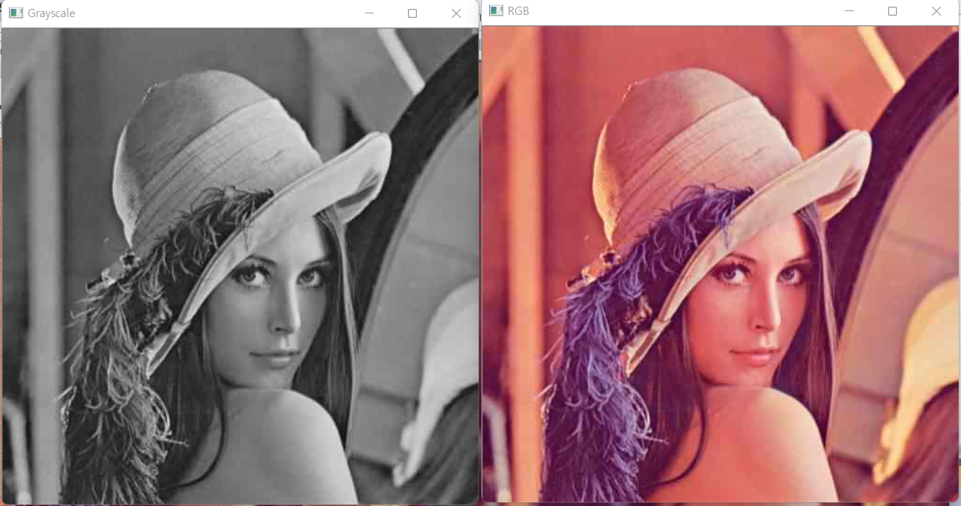

Original image

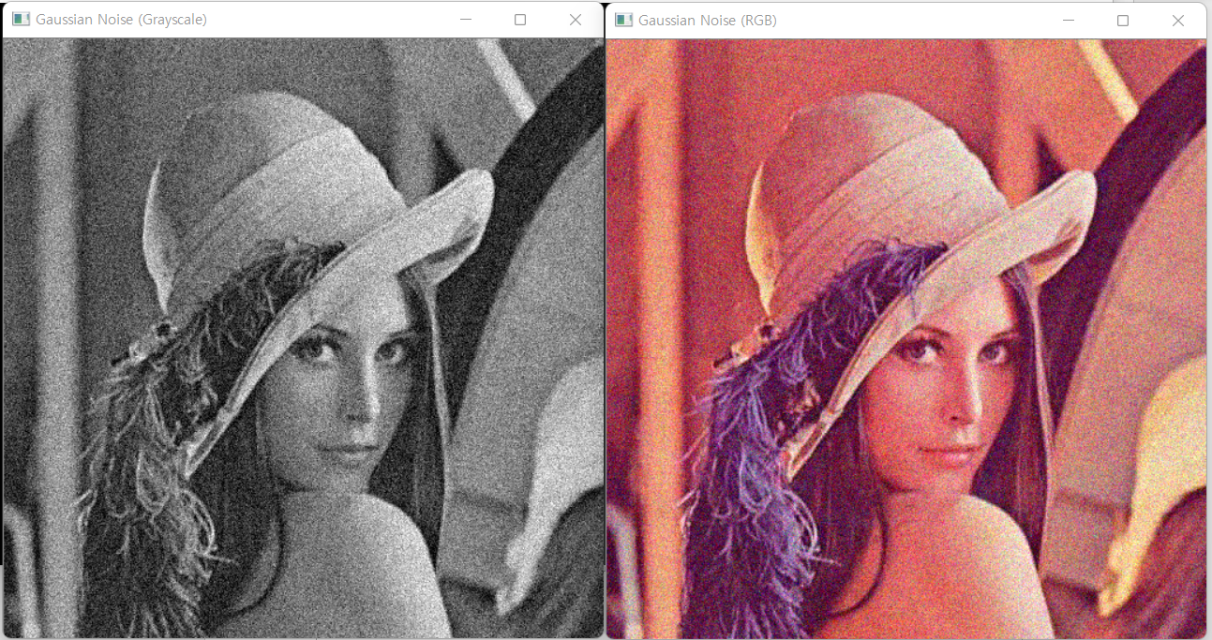

Image with gaussian noise (mean=0, standard deviation=0.1)

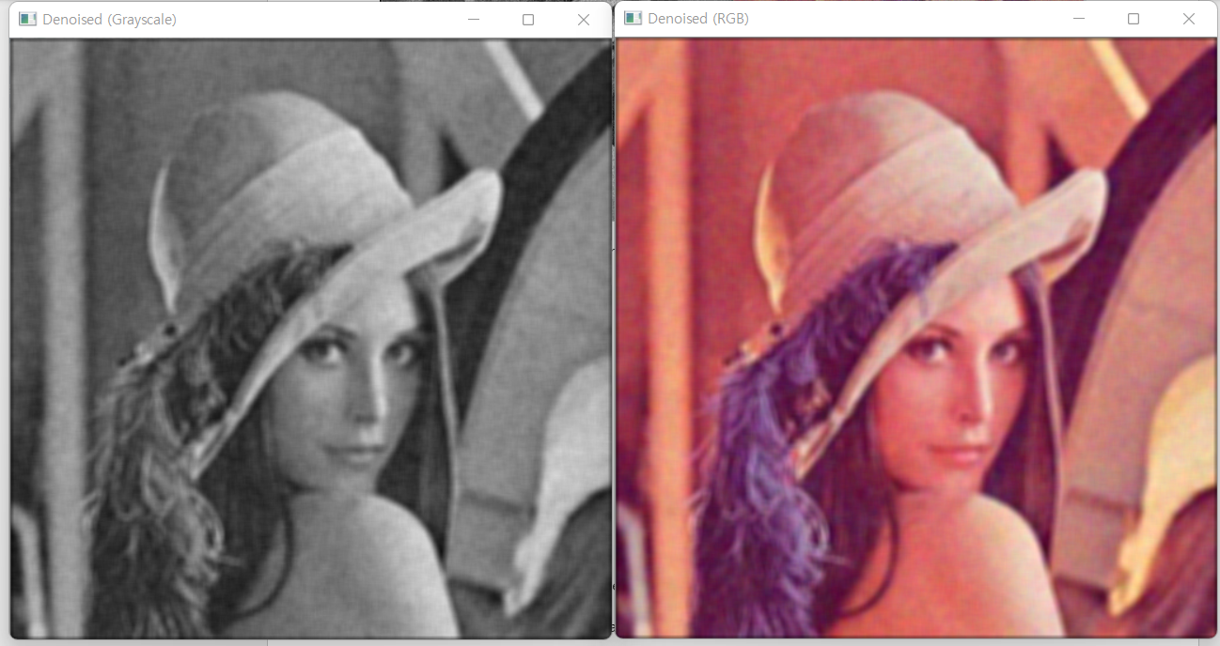

Gaussian noise removed with gaussian filtering (7x7, sigma_t=10, sigma_s=10, zero-padding)

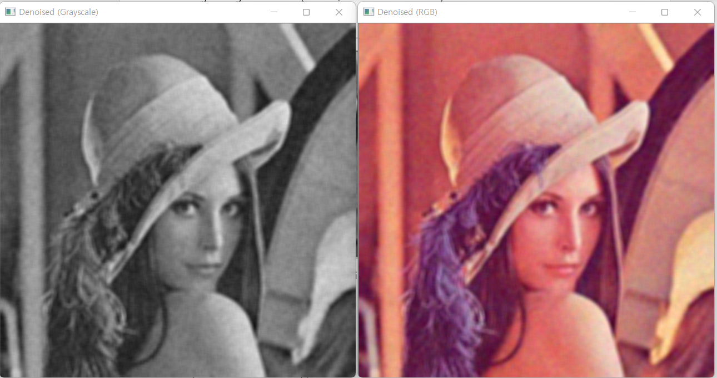

Gaussian noise removed with gaussian filtering (7x7, sigma_t=10, sigma_s=10, mirroring)

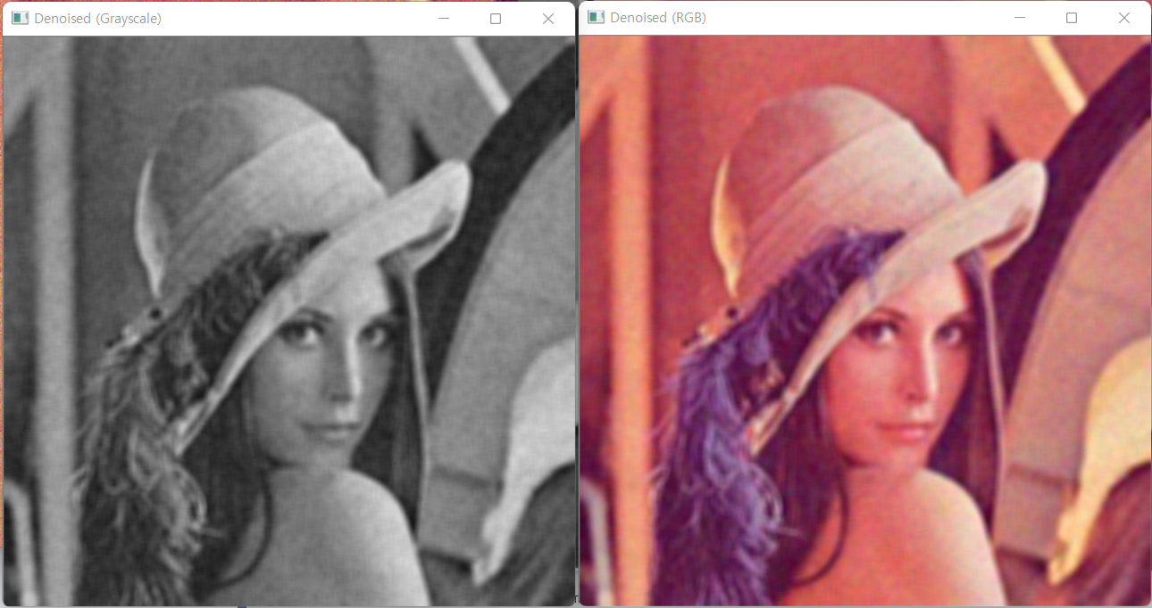

Gaussian noise removed with gaussian filtering (7x7, sigma_t=10, sigma_s=10, adjustkernel)

*gaussian_noise_bilaternal.cpp*

1. Code Explanation

1) overall explanation

Gaussian noise를 가진 각각의 흑백, 컬러 이미지를 생성한 뒤, bilateral filter를 이용하여 noise를 제거한 이미지들을 생성한다.

2) code

Bilateralfilter_Gray 에서

for (int i = 0; i < row; i++) {

for (int j = 0; j < col; j++) {

//filter kernel

denom = 0.0;

if (!strcmp(opt, "zero-padding")) {

for (int x = -n; x <= n; x++) { // compute denominator value and elements of kernel

for (int y = -n; y <= n; y++) {

float value1;

if ((i + x <= row - 1) && (i + x >= 0) && (j + y <= col - 1) && (j + y >= 0)) {

value1 = exp(-(pow(x, 2) / (2 * pow(sigma_s, 2))) - (pow(y, 2) / (2 * pow(sigma_t, 2))))

* exp(-pow((input.at<G>(i, j) - input.at<G>(i + x, j + y)), 2) / (2 * pow(sigma_r, 2)));

}

else

value1 = exp(-(pow(x, 2) / (2 * pow(sigma_s, 2))) - (pow(y, 2) / (2 * pow(sigma_t, 2))))

* exp(-pow((input.at<G>(i, j) - 0), 2) / (2 * pow(sigma_r, 2)));

kernel.at<float>(x + n, y + n) = value1;

denom += value1;

}

}

for (int x = -n; x <= n; x++) { // divide kernel with Denominator

for (int y = -n; y <= n; y++) {

kernel.at<float>(x + n, y + n) /= denom;

}

}

}

else if (!strcmp(opt, "mirroring")) {

for (int x = -n; x <= n; x++) {

for (int y = -n; y <= n; y++) {

float value1 = 0.0;

if (i + x > row - 1) { //mirroring for the border pixels

tempa = i - x;

}

else if (i + x < 0) {

tempa = -(i + x);

}

else {

tempa = i + x;

}

if (j + y > col - 1) {

tempb = j - y;

}

else if (j + y < 0) {

tempb = -(j + y);

}

else {

tempb = j + y;

}

value1 = exp(-(pow(x, 2) / (2 * pow(sigma_s, 2))) - (pow(y, 2) / (2 * pow(sigma_t, 2))))

* exp(-pow((input.at<G>(i, j) - input.at<G>(tempa, tempb)), 2) / (2 * pow(sigma_r, 2)));

kernel.at<float>(x + n, y + n) = value1;

denom += value1;

}

}

for (int x = -n; x <= n; x++) { // divide kernel with Denominator

for (int y = -n; y <= n; y++) {

kernel.at<float>(x + n, y + n) /= denom;

}

}

}

else if (!strcmp(opt, "adjustkernel")) {

for (int x = -n; x <= n; x++) { // compute denominator value and elements of kernel

for (int y = -n; y <= n; y++) {

float value1;

if ((i + x <= row - 1) && (i + x >= 0) && (j + y <= col - 1) && (j + y >= 0)) {

value1 = exp(-(pow(x, 2) / (2 * pow(sigma_s, 2))) - (pow(y, 2) / (2 * pow(sigma_t, 2))))

* exp(-pow((input.at<G>(i, j) - input.at<G>(i + x, j + y)), 2) / (2 * pow(sigma_r, 2)));

}

else value1 = 0.0;

kernel.at<float>(x + n, y + n) = value1;

denom += value1;

}

}

for (int x = -n; x <= n; x++) { // divide kernel with Denominator

for (int y = -n; y <= n; y++) {

kernel.at<float>(x + n, y + n) /= denom;

}

}

}

/*-------------------------------------------------------------------------------------------------------------*/

//convolution

if (!strcmp(opt, "zero-padding")) {

float sum1 = 0.0;

for (int x = -n; x <= n; x++) { // for each kernel window

for (int y = -n; y <= n; y++) {

kernelvalue = kernel.at<float>(x + n, y + n);

if ((i + x <= row - 1) && (i + x >= 0) && (j + y <= col - 1) && (j + y >= 0)) { //if the pixel is not a border pixel

sum1 += kernelvalue * (float)(input.at<G>(i + x, j + y));

}

}

}

output.at<G>(i, j) = (G)sum1;

}

else if (!strcmp(opt, "mirroring")) {

float sum1 = 0.0;

for (int x = -n; x <= n; x++) { // for each kernel window

for (int y = -n; y <= n; y++) {

kernelvalue = kernel.at<float>(x + n, y + n);

if (i + x > row - 1) { //mirroring for the border pixels

tempa = i - x;

}

else if (i + x < 0) {

tempa = -(i + x);

}

else {

tempa = i + x;

}

if (j + y > col - 1) {

tempb = j - y;

}

else if (j + y < 0) {

tempb = -(j + y);

}

else {

tempb = j + y;

}

sum1 += kernelvalue * (float)(input.at<G>(tempa, tempb));

}

}

output.at<G>(i, j) = (G)sum1;

}

else if (!strcmp(opt, "adjustkernel")) {

float sum1 = 0.0;

float sum2 = 0.0;

for (int x = -n; x <= n; x++) { // for each kernel window

for (int y = -n; y <= n; y++) {

//w'(s,t) = (0<=i+a<=H-1 && 0<=j+t<=W-1 ? w(s,t) : 0 )

kernelvalue = kernel.at<float>(x + n, y + n);

if ((i + x <= row - 1) && (i + x >= 0) && (j + y <= col - 1) && (j + y >= 0)) {

sum1 += kernelvalue * (float)(input.at<G>(i + x, j + y));

sum2 += kernelvalue;

}

}

}

output.at<G>(i, j) = (G)(sum1 / sum2);

}

}

}

Bilateralfilter_RGB

for (int i = 0; i < row; i++) {

for (int j = 0; j < col; j++) {

//filter kernel

denom = 0.0;

if (!strcmp(opt, "zero-padding")) {

for (int x = -n; x <= n; x++) { // compute denominator value and elements of kernel

for (int y = -n; y <= n; y++) {

float value1;

if ((i + x <= row - 1) && (i + x >= 0) && (j + y <= col - 1) && (j + y >= 0)) {

value1 = exp(-(pow(x, 2) / (2 * pow(sigma_s, 2))) - (pow(y, 2) / (2 * pow(sigma_t, 2))))

* exp(-pow((input.at<C>(i, j)[0] - input.at<C>(i + x, j + y)[0]), 2) / (2 * pow(sigma_r, 2)))

* exp(-pow((input.at<C>(i, j)[1] - input.at<C>(i + x, j + y)[1]), 2) / (2 * pow(sigma_r, 2)))

* exp(-pow((input.at<C>(i, j)[2] - input.at<C>(i + x, j + y)[2]), 2) / (2 * pow(sigma_r, 2)));

}

else

value1 = exp(-(pow(x, 2) / (2 * pow(sigma_s, 2))) - (pow(y, 2) / (2 * pow(sigma_t, 2))))

* exp(-pow((input.at<C>(i, j)[0] - 0), 2) / (2 * pow(sigma_r, 2)))

* exp(-pow((input.at<C>(i, j)[1] - 0), 2) / (2 * pow(sigma_r, 2)))

* exp(-pow((input.at<C>(i, j)[2] - 0), 2) / (2 * pow(sigma_r, 2)));

kernel.at<float>(x + n, y + n) = value1;

denom += value1;

}

}

for (int x = -n; x <= n; x++) { // divide kernel with Denominator

for (int y = -n; y <= n; y++) {

kernel.at<float>(x + n, y + n) /= denom;

}

}

}

else if (!strcmp(opt, "mirroring")) {

for (int x = -n; x <= n; x++) {

for (int y = -n; y <= n; y++) {

float value1 = 0.0;

if (i + x > row - 1) { //mirroring for the border pixels

tempa = i - x;

}

else if (i + x < 0) {

tempa = -(i + x);

}

else {

tempa = i + x;

}

if (j + y > col - 1) {

tempb = j - y;

}

else if (j + y < 0) {

tempb = -(j + y);

}

else {

tempb = j + y;

}

value1 = exp(-(pow(x, 2) / (2 * pow(sigma_s, 2))) - (pow(y, 2) / (2 * pow(sigma_t, 2))))

* exp(-pow((input.at<C>(i, j)[0] - input.at<C>(tempa, tempb)[0]), 2) / (2 * pow(sigma_r, 2)))

* exp(-pow((input.at<C>(i, j)[1] - input.at<C>(tempa, tempb)[1]), 2) / (2 * pow(sigma_r, 2)))

* exp(-pow((input.at<C>(i, j)[2] - input.at<C>(tempa, tempb)[2]), 2) / (2 * pow(sigma_r, 2)));

kernel.at<float>(x + n, y + n) = value1;

denom += value1;

}

}

for (int x = -n; x <= n; x++) { // divide kernel with Denominator

for (int y = -n; y <= n; y++) {

kernel.at<float>(x + n, y + n) /= denom;

}

}

}

else if (!strcmp(opt, "adjustkernel")) {

for (int x = -n; x <= n; x++) { // compute denominator value and elements of kernel

for (int y = -n; y <= n; y++) {

float value1;

if ((i + x <= row - 1) && (i + x >= 0) && (j + y <= col - 1) && (j + y >= 0)) {

value1 = exp(-(pow(x, 2) / (2 * pow(sigma_s, 2))) - (pow(y, 2) / (2 * pow(sigma_t, 2))))

* exp(-pow((input.at<C>(i, j)[0] - input.at<C>(i + x, j + y)[0]), 2) / (2 * pow(sigma_r, 2)))

* exp(-pow((input.at<C>(i, j)[1] - input.at<C>(i + x, j + y)[1]), 2) / (2 * pow(sigma_r, 2)))

* exp(-pow((input.at<C>(i, j)[2] - input.at<C>(i + x, j + y)[2]), 2) / (2 * pow(sigma_r, 2)));

}

else value1 = 0.0;

kernel.at<float>(x + n, y + n) = value1;

denom += value1;

}

}

for (int x = -n; x <= n; x++) { // divide kernel with Denominator

for (int y = -n; y <= n; y++) {

kernel.at<float>(x + n, y + n) /= denom;

}

}

}

/*-------------------------------------------------------------------------------------------------------------*/

//convolution

if (!strcmp(opt, "zero-padding")) {

float sum1_r = 0.0;

float sum1_g = 0.0;

float sum1_b = 0.0;

for (int x = -n; x <= n; x++) { // for each kernel window

for (int y = -n; y <= n; y++) {

kernelvalue = kernel.at<float>(x + n, y + n);

if ((i + x <= row - 1) && (i + x >= 0) && (j + y <= col - 1) && (j + y >= 0)) { //if the pixel is not a border pixel

sum1_r += kernelvalue * (float)(input.at<C>(i + x, j + y)[0]); //0:R, 1:G, 2:B

sum1_g += kernelvalue * (float)(input.at<C>(i + x, j + y)[1]);

sum1_b += kernelvalue * (float)(input.at<C>(i + x, j + y)[2]);

}

}

}

output.at<C>(i, j)[0] = (G)sum1_r;

output.at<C>(i, j)[1] = (G)sum1_g;

output.at<C>(i, j)[2] = (G)sum1_b;

}

else if (!strcmp(opt, "mirroring")) {

float sum1_r = 0.0;

float sum1_g = 0.0;

float sum1_b = 0.0;

for (int x = -n; x <= n; x++) { // for each kernel window

for (int y = -n; y <= n; y++) {

kernelvalue = kernel.at<float>(x + n, y + n);

if (i + x > row - 1) { //mirroring for the border pixels

tempa = i - x;

}

else if (i + x < 0) {

tempa = -(i + x);

}

else {

tempa = i + x;

}

if (j + y > col - 1) {

tempb = j - y;

}

else if (j + y < 0) {

tempb = -(j + y);

}

else {

tempb = j + y;

}

sum1_r += kernelvalue * (float)(input.at<C>(tempa, tempb)[0]);

sum1_g += kernelvalue * (float)(input.at<C>(tempa, tempb)[1]);

sum1_b += kernelvalue * (float)(input.at<C>(tempa, tempb)[2]);

}

}

output.at<C>(i, j)[0] = (G)sum1_r;

output.at<C>(i, j)[1] = (G)sum1_g;

output.at<C>(i, j)[2] = (G)sum1_b;

}

else if (!strcmp(opt, "adjustkernel")) {

float sum1_r = 0.0;

float sum1_g = 0.0;

float sum1_b = 0.0;

float sum2 = 0.0;

for (int x = -n; x <= n; x++) { // for each kernel window

for (int y = -n; y <= n; y++) {

//w'(s,t) = (0<=i+a<=H-1 && 0<=j+t<=W-1 ? w(s,t) : 0 )

kernelvalue = kernel.at<float>(x + n, y + n);

if ((i + x <= row - 1) && (i + x >= 0) && (j + y <= col - 1) && (j + y >= 0)) {

sum1_r += kernelvalue * (float)(input.at<C>(i + x, j + y)[0]);

sum1_g += kernelvalue * (float)(input.at<C>(i + x, j + y)[1]);

sum1_b += kernelvalue * (float)(input.at<C>(i + x, j + y)[2]);

sum2 += kernelvalue;

}

}

}

output.at<C>(i, j)[0] = (G)(sum1_r / sum2);

output.at<C>(i, j)[1] = (G)(sum1_g / sum2);

output.at<C>(i, j)[2] = (G)(sum1_b / sum2);

}

}

}

3) analysis and explanation of the code

1. Bilateral filtering의 kernel에는 input.at<G>(i + x, j + y) 이 포함되므로, Zero-padding, mirroring, adjustkernel 각 boundary processing method에 따라 filter kernel을 채운다.
2. 새롭게 생성한 kernel에 대해 convolution을 수행한다.

2. Results & analysis and explanation

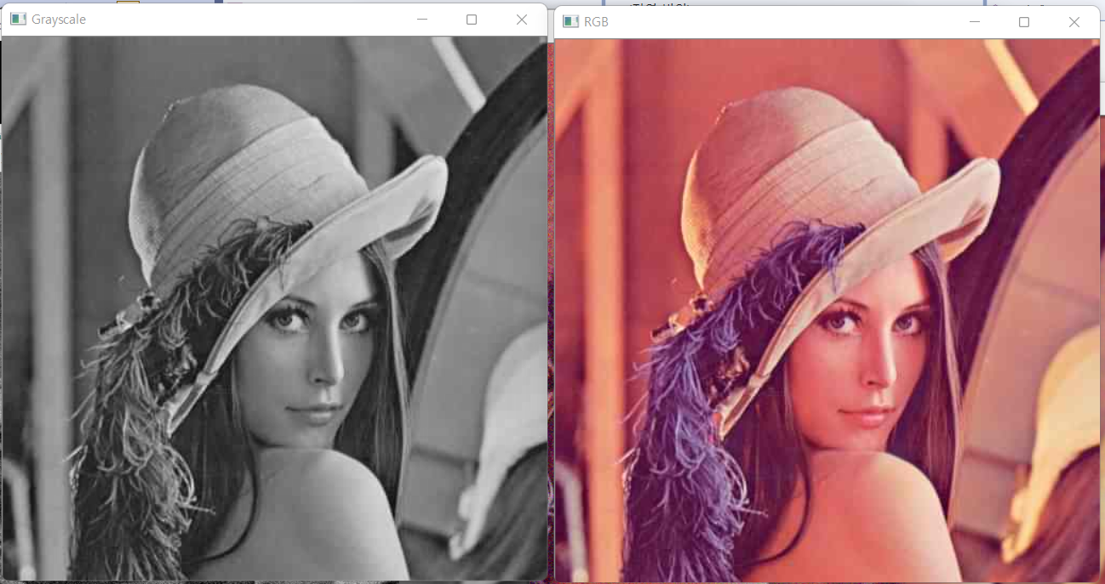

Original Image

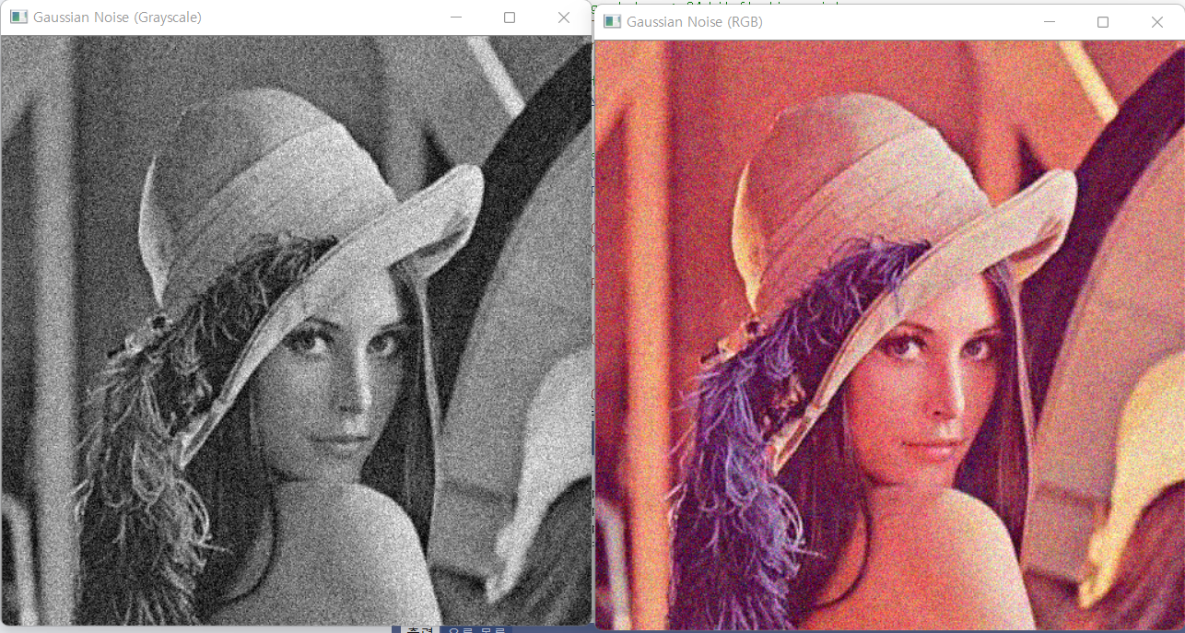

Image with gaussian noise (mean=0, standard deviation=0.1)

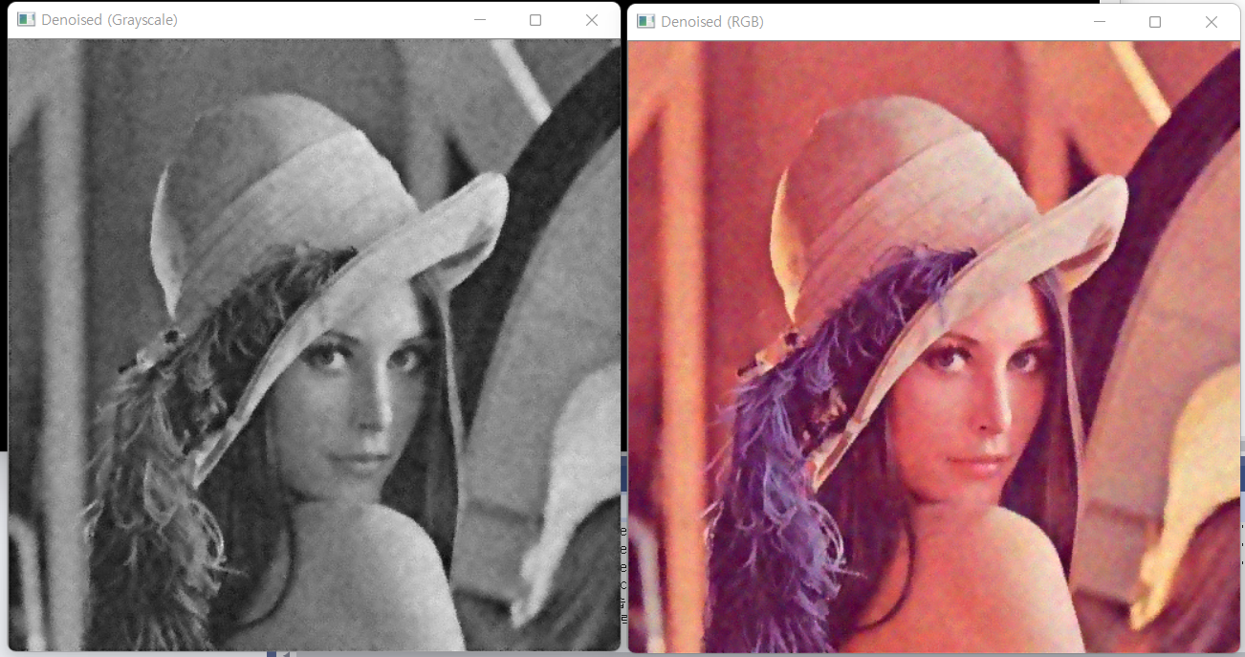

Gaussian noise removed with bilateral filtering (7x7, sigma_t=10, sigma_s=10, sigma_r=0.2, zero-paddle)

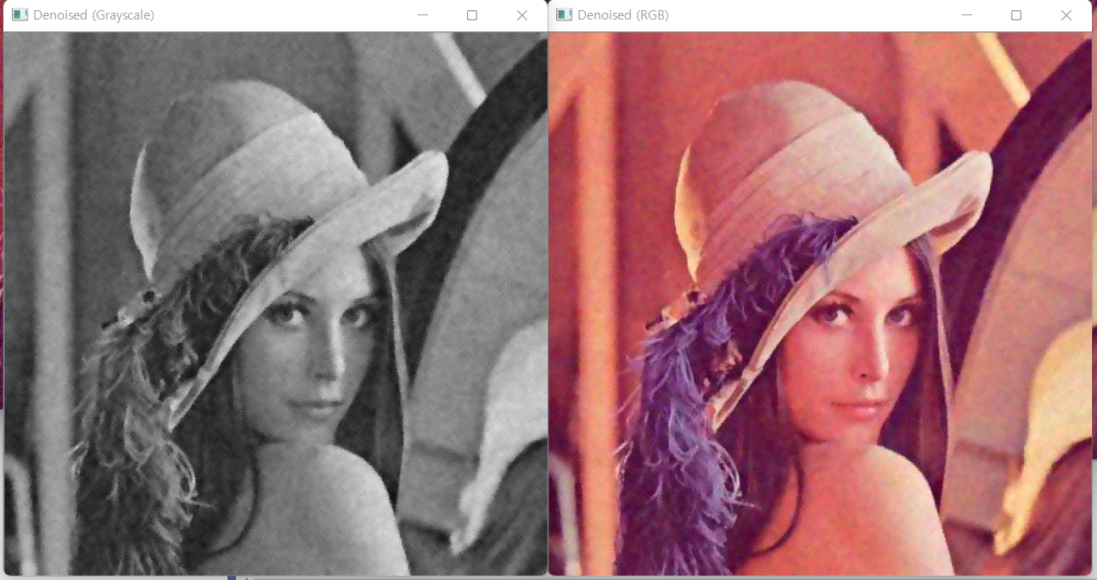

Gaussian noise removed with bilateral filtering (7x7, sigma_t=10, sigma_s=10, sigma_r=0.2, mirroring)

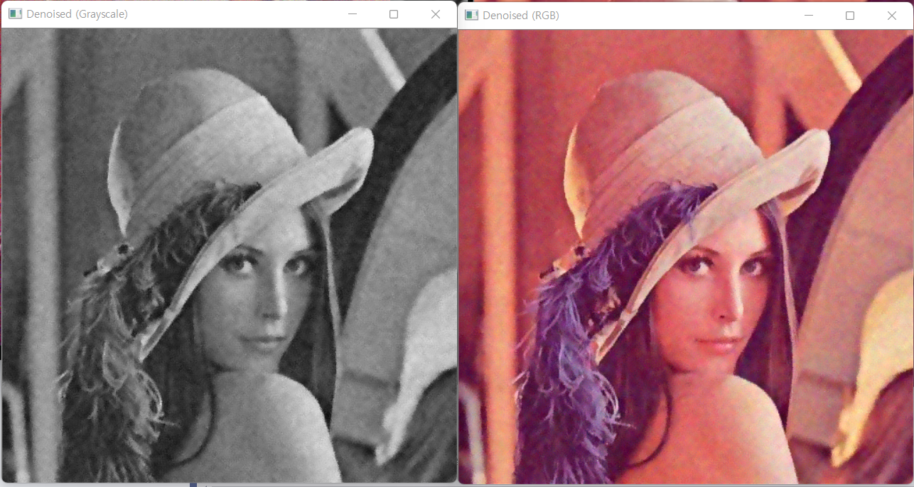

Gaussian noise removed with bilateral filtering (7x7, sigma_t=10, sigma_s=10, sigma_r=0.2, adjusting filter kernel)